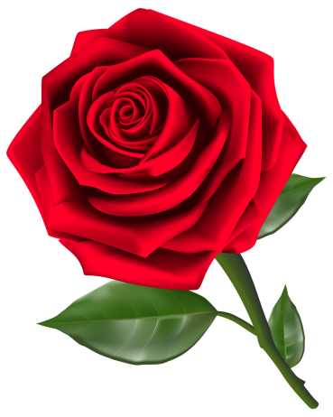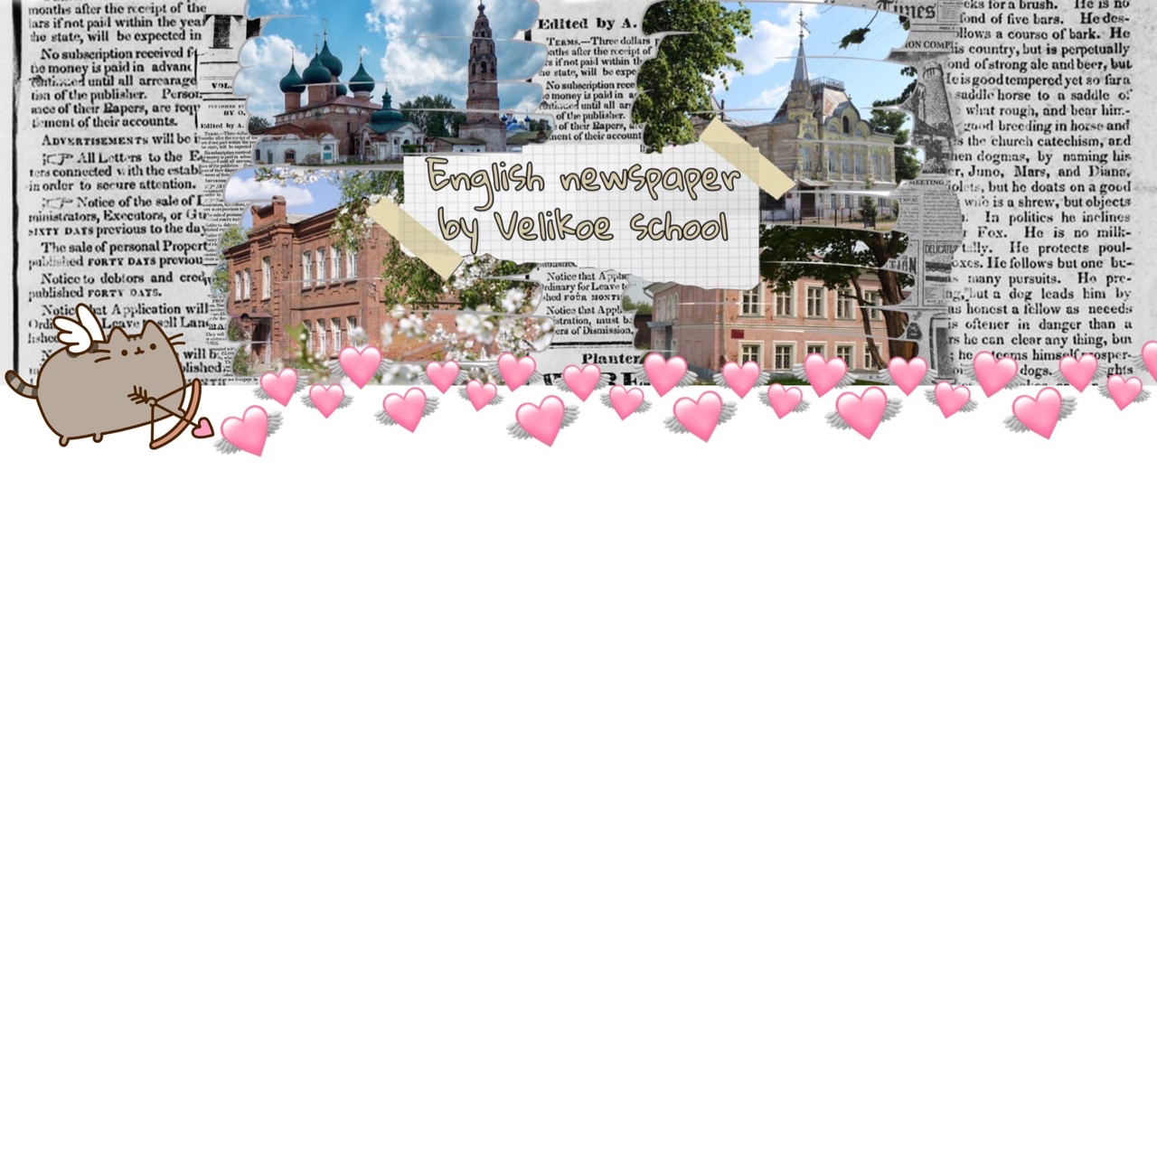

14 facts about Valentine's Day

1. First Valentine Was Written From a Prison.

2. About 1 billion Valentine’s Day cards are exchanged each year. This makes it the second largest seasonal card-sending time of the year.

3. Red roses were the favorite flowers of Venus, the Roman goddess of love.

4. In the days of Queen Victoria, it was considered bad omen in England to sign valentines.

5. The Italians called February 14 "sweet day." It is chocolate and other confectionery that is the most common gift in this country.

6. For the Japanese, Valentine's Day is a men's holiday.

7. Valentine's Day is officially banned in Iran and Saudi Arabia.

8. Richard Cadbury (founder of the chocolate empire) first came up with the idea of selling chocolates in a heart-shaped box in 1868 as a Valentine's Day gift.

A wonderful holiday is approaching - Valentine's Day, the patron saint of all lovers. It is shrouded in legends and secrets, and this is not surprising, because the history of this holiday and even the personality of St. Valentine himself have always been surrounded by mysteries and contradictions. Are you interested in these facts? Then we recommend reading this article!

Valentine’s Day!

February 2021



9. In 1537, King Henry VII of England (the same one who was married 6 times and excommunicated from the Roman Catholic Church due to a desire to divorce his first wife) officially declared February 14 a holiday in honor of St. Valentine.

10. There is no exact information about the origin of the holiday, only assumptions and legends.

11. The main characters in Shakespeare's play Romeo and Juliet lived in Verona. Every year, thousands of Valentines are sent there in the name of Juliet.

12. The oldest Valentine's card dates back to 1400 and is in the British Museum in London.

13. The image of St. Valentine may belong to two people at once.

14. Valentine's Day is celebrated in America, Italy, the United Kingdom, Mexico, Canada, France, Australia, Denmark.

*Matveeva Victoria*



You have received a letter from your English-speaking pen friend Alice who writes

... I love Valentine's Day. There is an amazing customary in our school to give each other sweets, so everyone gets a gift. Do you love this holiday? What are you doing at school this day? Is there a Russian counterpart to this holiday?

By the way, I've begun collecting badges...

Write a letter to Alice. In your letter answer her questions and ask 3 questions about her new HOBBY. Write 100—140 words.

A letter

I’m a tenth-grade student. In my class there are nine people: five boys and four girls. There were always few of us in the class, a maximum of fifteen people. We were always friendly. We often quarreled among ourselves and it was not for long. But it was all up to the tenth grade. There are very few of us now. That’s why we have few conflicts. We try to study well.

Our class is rare winner in Olympiads. But we think that it is not an indicator of our knowledge. Our class had a hard time during distance studying. We have recently written the General State Exam. We really tried to do our best, but distance learning-studying influenced on our appraisals...

I really miss the ninth grade, because it was the best time. In the ninth class-grade were my first real relationship and it was easier to learn-study. But distance learning-studying ruined everything.

*Denis Gribanov*

My class

Think!

A letter

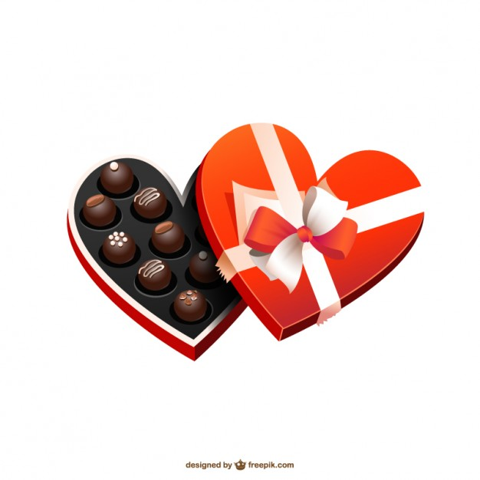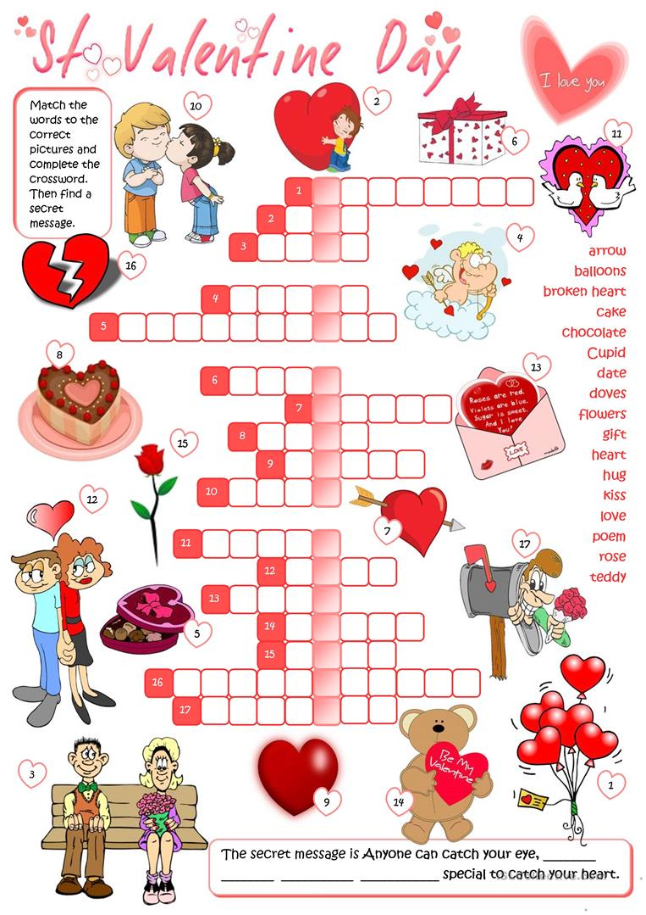

Few of us – мало кто из нас

To do our best – чтобы сделать все возможное

Appraisals – оценки

To ruin – разрушить

Sweethearts – возлюбленные

Counterpart – аналог

Badges – значки

Arrow – стрела

Doves – голуби

Catch – зацепить

Violet – фиалка

Patron – покровитель

Shrouded – окутанный

Surrounded by mysteries and contradictions – в окружении загадок и противоречий

Prison – тюрьма

Omen – предзнаменование

Confectionery – кондитерские изделия

Excommunicated – отлучен от церкви

Desire to divorce – желание развестись

Honor – честь

Assumptions – предположения

Belong – принадлежать

Interesting expressions

Gavrilov-Yam

Russia

08.02.2021

Dear Alice,

Thank you very much for the letter. It was nice to hear from you again.

In your letter, you asked me about Valentine’s Day. Well, I love this holiday because it gives people happiness and joy. Also, for sweethearts this holiday is another reason to show their love. Actually, there is a tradition in our school – students put valentines in a special mailbox for people they like. Honestly, there is a Day of Family, Love and Fidelity, but I don’t celebrate a Russian counterpart to Valentine’s Day.

By the way, why did you choose this type of hobby? Is this hobby popular now? How much badges have you collected so far?

I look forward to hearing from you.

Best wishes,

Dugieva Madina

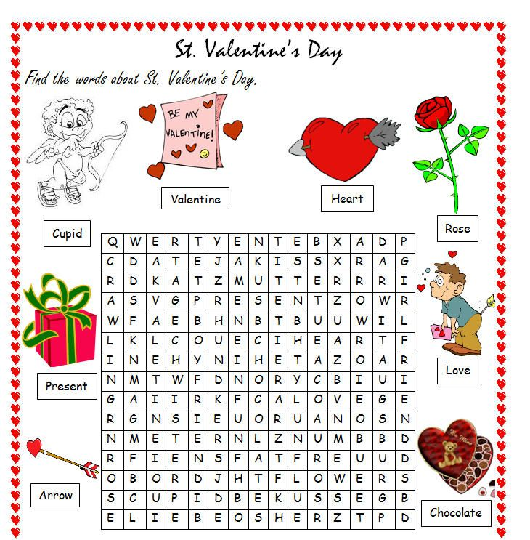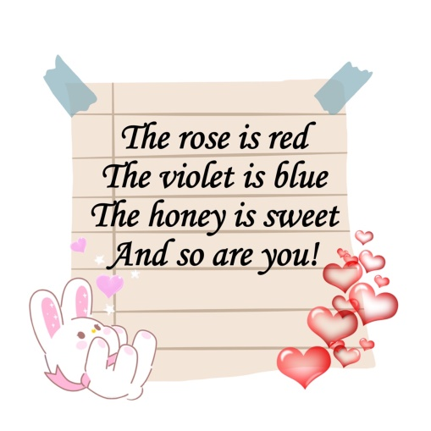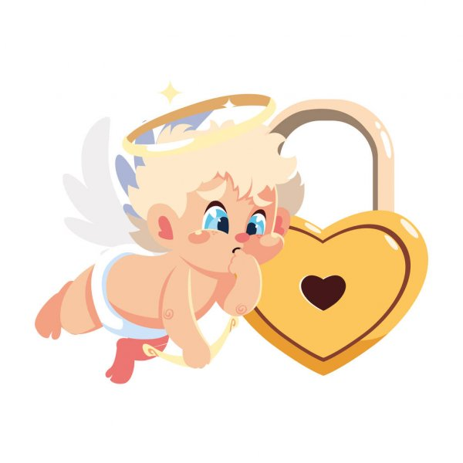

Authors of the issue: Mazilova Alina, Dugieva Madina, Matveeva Victoria, Gribanov Denis, Naumova Alina, Morugina Polina.

For kids!